Absolute Encoder (BiSS-C) Set Up

This document describes BiSS-C encoder set up in Turbo PMAC. Current version doesn’t include motor set up. Related information can be found in GEO Brick LV manual.

1. Configure Global Control Registers (GEO Brick LV manual pp.95) and Channel Control Registers (GEO Brick LV manual pp.96).

Example (26-bit BiSS-C encoder on channel 7):

|  |
| --- |
| M5990..5991->* ; Self-referenced M-Variables  M5990..5991=0 ; Reset at download  //========================= GLOBAL CONTROL REGISTERS ======================================//  #define SSIGlobalCtrl5_8 M5990 ; Channels 5-8 BiSS global control register  SSIGlobalCtrl5_8->X:$78B3F,0,24,U ; Channels 5-8 BiSS global control register address  //======================== CHANNEL CONTROL REGISTERS ======================================//  #define Ch7SSICtrl M5991 ; Channel 1 BiSS control register  Ch7SSICtrl->X:$78B38,0,24,U ; Channel 7 BiSS control register Address  //========= POWER-ON PLC EXAMPLE, GLOBAL & CHANNEL CONTROL REGISTERS ======================//  Open PLC 8 Clear  SSIGlobalCtrl5_8=$63000B ; Trigger at Phase, 1 MHz serial Clock (M=99, N=0) –User Input  Ch7SSICtrl=$21149A ; Channel 7, BiSS-C protocol, 26-bit resolution –User Input  I5111=500*8388608/I10 while(I5111>0) endw ; ½ sec delay  #7$*  Dis plc 8 ; Execute once on power-up or reset  Close |

1. Configure Encoder Conversion Table

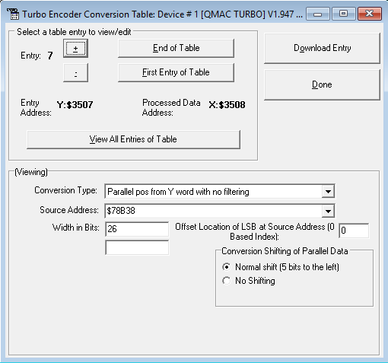

1. Set I variables

I703=$3508

I704=$3508

I780=2 ; absolute encoder power-on read enable ; (GEO Brick LV manual pp.114)

I710=$78B38 ; (GEO Brick LV manual pp.114)

I195=$1A0000 ; (GEO Brick LV manual pp.114)